**INSTALLATION AND USER INSTRUCTIONS**

**ChorSSI**

Model-driven Approach for Modelling and Executing Self-Sovereign Identity Systems on Blockchain

Month 20YY  
Version X.XX

**DISCLAIMER**

Lorem ipsum dolor sit amet, consectetur adipiscing elit. Etiam at porta est, et lobortis sem. Duis imperdiet in nisl sed luctus. Vivamus hendrerit molestie urna, eu viverra velit porttitor sit amet. Donec nec ligula vitae elit venenatis tincidunt. Curabitur in est placerat, lobortis ante sit amet, tincidunt tortor. Duis ligula dui, tincidunt ut aliquam quis, gravida in libero. Nunc vel lacinia turpis. Etiam metus neque, ultricies eget odio eu, mollis ultricies lectus. Vestibulum consectetur turpis eget diam dignissim posuere.

Copyright © 20YY by [Company]

All rights reserved. No part of this publication may be reproduced, distributed, or transmitted in any form or by any means, including photocopying, recording, or other electronic or mechanical methods, without the prior written permission of the publisher. For permission requests, write to the publisher, addressed “Attention: Permissions Coordinator,” at the address below.

[Company] [Address]   
[Phone] [Fax] [Website]

# Table of Contents

1 PREFACE 7

1.1 Description of the user 7

1.2 Conventions used in this manual 7

1.3 Explanation of safety warnings 8

1.4 Retaining instructions 8

1.5 Obtaining documentation and information 9

1.5.1 Internet 9

1.5.2 Ordering documentation 9

1.5.3 Documentation feedback 9

2 Description of the product 10

2.1 Purpose of the product 10

2.2 Technical data 10

2.3 Product Compliance 10

2.5 Product elements 11

2.6 Understanding the user interface 12

2.7 Operating panels 13

3 Safety instructions 14

3.1 How to use the product safely 14

3.1.1 Safety information for vulnerable people 14

3.1.2 Personal safety 14

3.1.3 Work area safety 14

3.1.4 Electrical safety 14

3.2 Graphical symbols 15

3.2.1 Explanation of safety information on the packaging and product 15

3.2.2 Explanation of graphical symbols in the user manual 15

4 Preparation 16

4.1 How to transport and store the product 16

4.1.1 Lifting, handing and transporting the product 16

4.1.2 Storing the product 16

4.2 How to install the product 17

4.2.1 Removal of the transport and packaging restraints 17

4.2.2 Unpacking the product 17

4.2.3 Packaging contents 18

4.2.4 Conditions for assembling 19

4.2.5 Installation of the product 20

4.3 How to commission the product 21

5 Operation/Use 22

5.1 How to use the product 22

5.1.1 Operational environment 22

5.1.2 Manual operating techniques 22

5.1.3 Local/Remote operation 22

5.1.4 Manual/Automatic operation 22

5.1.5 Starting/Stopping the product’s operation 23

5.1.6 Checks before using the product 23

5.1.7 Using the product 24

5.2 Software documentation 25

5.2.1 Setting up the product 25

5.2.2 Adding products with the software 26

5.2.3 Software settings 27

5.3 What to do in emergency and exceptional situations 28

5.3.1 Emergency situation 28

5.3.2 Exceptional situations 28

6 Maintenance and cleaning 29

6.1 How to maintain the product 29

6.1.1 Product maintenance by non-skilled persons 29

6.1.2 Product maintenance by skilled persons 29

6.1.3 Planned maintenance 31

6.2 How to clean the product 31

7 Troubleshooting and repair 32

7.1 How to Identify and solve problems 32

7.1.1 Troubleshooting and repair by non-skilled persons 32

7.1.2 Troubleshooting and repair by skilled persons 32

7.2 How to Repair the Product 33

7.2.1 Repair by non-skilled persons 33

7.2.2 Repair by skilled persons 36

8 DISPOSAL 39

8.1 How to disassemble the Product 39

8.2 How to recycle parts 39

8.3 How to dispose the product 39

8.3.1 Disposal of electronic components 39

8.3.2 Disposal of packaging waste 39

8.3.3 Disposal of batteries 40

Appendix A. Supplied accessories, consumables and spare parts 41

Supplied accessories 41

Consumables 41

Spare/replacement parts 41

Appendix B. Related documentation 42

Glossary 43

Index 44

# PREFACE

## Description of the user

[Provide a description of the user for which the user manual is intended. Describe the user type, for example if the intended user needs to be a skilled person and if there are more than one users (e.g. installer and operator or end-user)

Also provide information regarding restrictions on the users who are permitted to use the product together with any skills, training, certification or expertise required]

## Conventions used in this manual

The following style conventions are used in this document:

**Bold**Names of product elements, commands, options, programs, processes, services, and utilities Names of interface elements (such windows, dialog boxes, buttons, fields, and menus)  
Interface elements the user selects, clicks, presses, or types

*Italic*Publication titles referenced in text  
Emphasis (for example a new term)  
Variables

Courier  
System output, such as an error message or script  
URLs, complete paths, filenames, prompts, and syntax

User input variables  
< > Angle brackets surround user-supplied values  
[ ] Square brackets surround optional items  
| Vertical bar indicates alternate selections - the bar means “or”

## Explanation of safety warnings

**DANGER!** Danger indicates a hazard with a high level of risk which, if not avoided, will result in death or serious injury

**WARNING!** Warning indicates a hazard with a medium level of risk which, if not avoided, could result in death or serious injury.

**CAUTION!** Caution indicates a hazard with a low level of risk which, if not avoided, could result in minor or moderate injury.

***NOTICE*** Indicates information considered important, but not hazard-related.

## Retaining instructions

Read and understand this manual and its safety instructions before using this product. Failure to do so can result in serious injury or death.

Follow all the instructions. This will avoid fire, explosions, electric shocks or other hazards that may result in damage to property and/or severe or fatal injuries.

Keep all safety information and instructions for future reference and pass them on to subsequent users of the product.

## Obtaining documentation and information

### Internet

The latest version of the documentation is available at the following address: http://www.yourwebsite.com

Do you want to know how you can save on printing costs and reduce the environmental impact of your manuals? We can create your product information for both print and online. We know exactly what information needs to be provided printed and what can be placed online from a legal standpoint. Would you like to discuss the possibilities for HTML, video, AR or interactive user manuals? Ask us for the possibilities at [info@instrktiv.com](mailto:info@instrktiv.com)

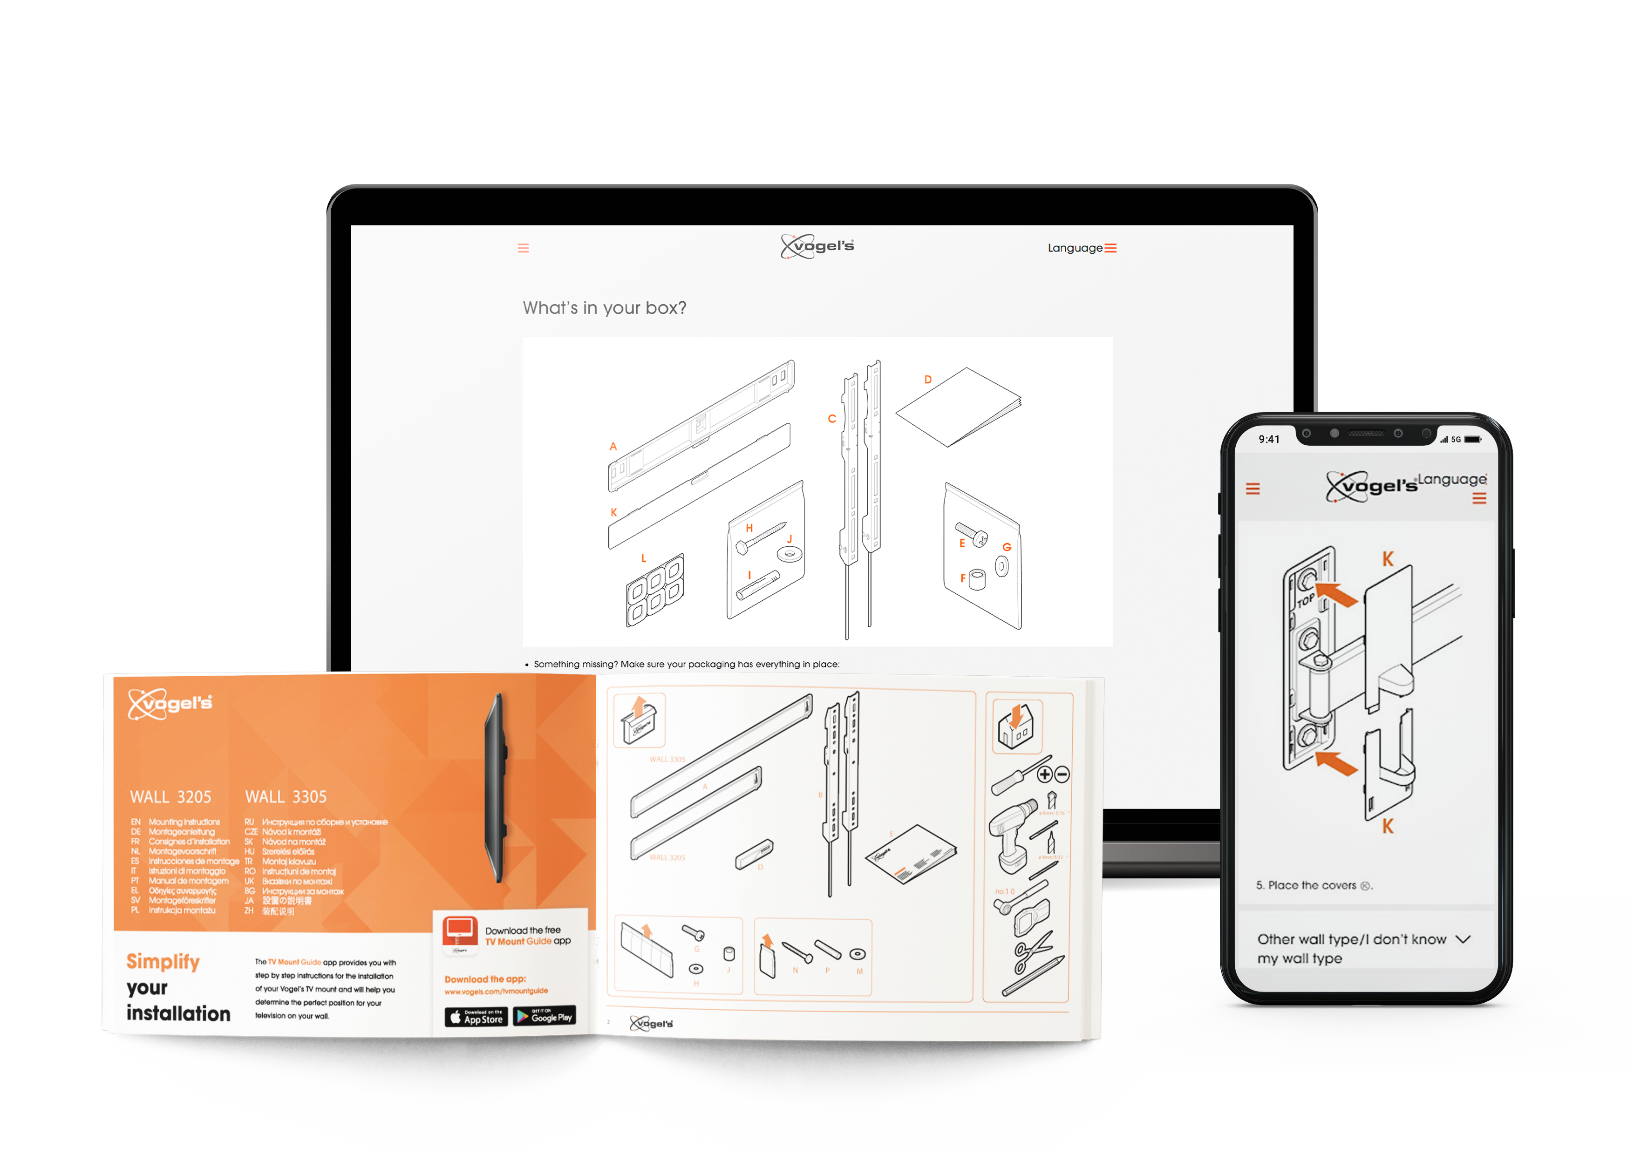

### Ordering documentation

Documentation, user instructions and technical information can be ordered by calling [Company] at [telephone number].

### Documentation feedback

If you are reading [Company] product documentation on the internet, any comments can be submitted on the support website. Comments can also be sent to [email address].

We appreciate your comments.

# Description of the product

## Purpose of the product

[Introduce the product and its purpose, mentioning key features and accessories]

Lorem ipsum dolor sit amet, consectetur adipiscing elit. Etiam at porta est, et lobortis sem. Duis imperdiet in nisl sed luctus. Vivamus hendrerit molestie urna, eu viverra velit porttitor sit amet. Donec nec ligula vitae elit venenatis tincidunt. Curabitur in est placerat, lobortis ante sit amet, tincidunt tortor. Duis ligula dui, tincidunt ut aliquam quis, gravida in libero. Nunc vel lacinia turpis. Etiam metus neque, ultricies eget odio eu, mollis ultricies lectus. Vestibulum consectetur turpis eget diam dignissim posuere.

## Technical data

|  |  |
| --- | --- |
| Parameter | Unit |
| Power | x W |
| Voltage | x V |
| Weight | x.xx kg (x.xx lbs) |
| Software version | 2.21 |
| Operating temperature | x to x °C ( x to x °F) |
| Humidity range | x to x % relative humidity (RH) |
| … |  |

*Table 1 Use tables for text that is difficult to understand in paragraph form (rule 72.1 of the INSTRKTIV User Manual Design Guide)*

## Product Compliance

[List any regulations, directives and/or standards to which the product complies]

This product complies to:

* Product standard A
* Product standard B

## Product elements

[Product image with callouts at main elements

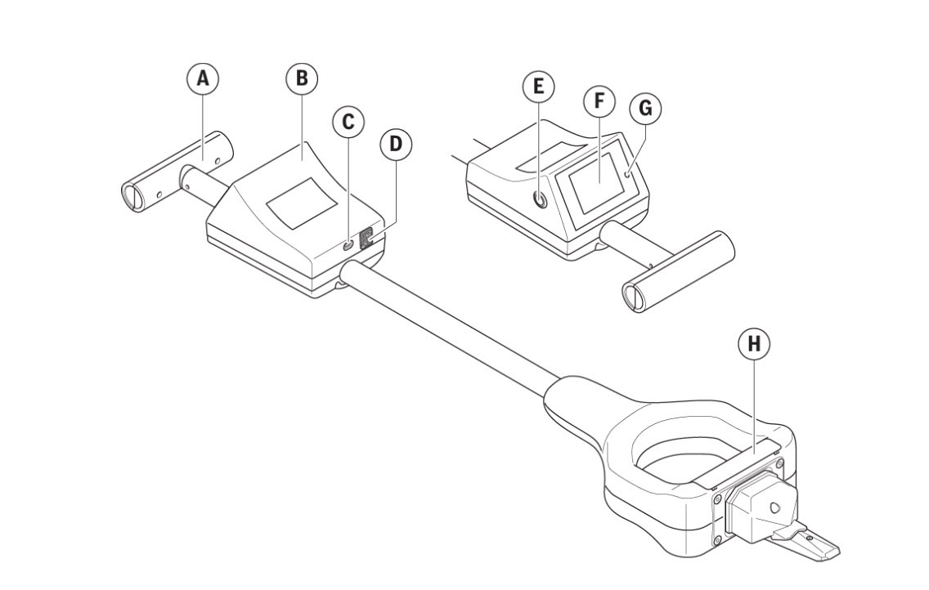

*Fig. 1 The use of captions is optional (rule 8.1 of the INSTRKTIV User Manual Design Guide)*

1. Element A
2. Element B
3. Element C
4. …

## Understanding the user interface

[Provide an explanation of the user interface, if applicable]

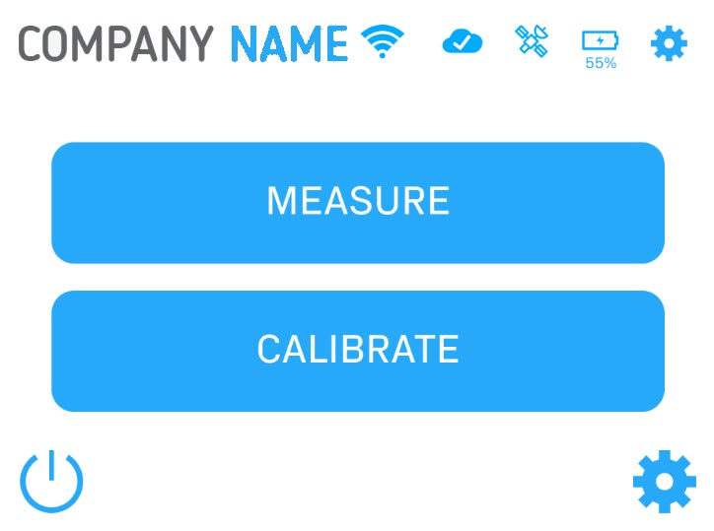

*Fig. 2 This is a caption*

|  |  |  |
| --- | --- | --- |
| **Nr.** | **Name** | **Function** |
| 1 | WiFi connection | Indicates if the device is connected to a WiFi network  - best WiFi signal strength  - bad WiFi signal strength  - no WiFi connection |
| 2 | Cloud connection |  |
|  | … | … |

*Table 2 This is a table*

## Operating panels

[Provide an explanation of all operating panels, if applicable]

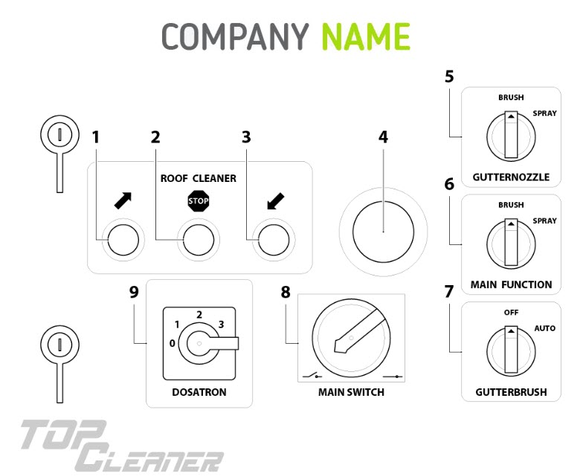

*Fig. 3 This is a caption*

# Safety instructions

[The grouped safety messages typically contain only those safety messages that apply to the entire product life cycle of the product]

**WARNING!** A good warning consists of three parts: The type and source of hazard, the consequences in the event of non-compliance and the measures to avoid the hazard. For example: WARNING! Hazardous voltage inside. Can shock, burn or cause death. Keep out.

## How to use the product safely

### Safety information for vulnerable people

* Lorem ipsum dolor sit amet
* Donec nec ligula vitae

### Personal safety

* Lorem ipsum dolor sit amet
* Donec nec ligula vitae

### Work area safety

* Lorem ipsum dolor sit amet
* Donec nec ligula vitae

### Electrical safety

* Lorem ipsum dolor sit amet
* Donec nec ligula vitae

## Graphical symbols

### Explanation of safety information on the packaging and product

|  |  |
| --- | --- |
| Symbol | Meaning |
| 3e736a18-9058-409e-9ba2-8b8b880ba4ab_200.png | Read and understand the manual and its safety instructions before using this product. |
|  |  |
|  |  |
|  |  |

*Table 3 This is a table*

### Explanation of graphical symbols in the user manual

|  |  |
| --- | --- |
| Symbol | Meaning |
|  |  |
|  |  |
|  |  |
|  |  |

*Table 4 This is a table*

# Preparation

## How to transport and store the product

### Lifting, handing and transporting the product

[Provide lifting, handling and transporting information, if applicable]

**To lift the product safely:**

1. Number steps using 1, 2, 3 (rule 53.3 of the INSTRKTIV User Manual Design Guide)
2. Use short sentences with one instruction in each sentence (rule 53.4 of the INSTRKTIV User Manual Design Guide).
3. Begin instructions with a strong and active verb in the imperative (command) form (rule 53.5 of the INSTRKTIV User Manual Design Guide).

**To handle the product safely:**

1. Do this.
2. Complete an action.
3. Do that.

**To transport the product safely:**

1. Do this.
2. Complete an action.
3. Do that.

### Storing the product

[Provide storage information, if applicable]

Lorem ipsum dolor sit amet, consectetur adipiscing elit. Etiam at porta est, et lobortis sem. Duis imperdiet in nisl sed luctus.

**To store the product safely:**

1. Do this.
2. Complete an action.
3. Do that.

## How to install the product

### Removal of the transport and packaging restraints

Lorem ipsum dolor sit amet, consectetur adipiscing elit. Etiam at porta est, et lobortis sem. Duis imperdiet in nisl sed luctus.

**Lorem ipsum:**

1. Do this.
2. Complete an action.
3. Do that.

### Unpacking the product

Lorem ipsum dolor sit amet, consectetur adipiscing elit. Etiam at porta est, et lobortis sem. Duis imperdiet in nisl sed luctus. **Lorem ipsum:**

1. Do this.
2. Complete an action.
3. Do that.

### Packaging contents

Lorem ipsum dolor sit amet, consectetur adipiscing elit. Etiam at porta est, et lobortis sem. Duis imperdiet in nisl sed luctus. **Lorem ipsum:**

1. Part A
2. Part B
3. Part C

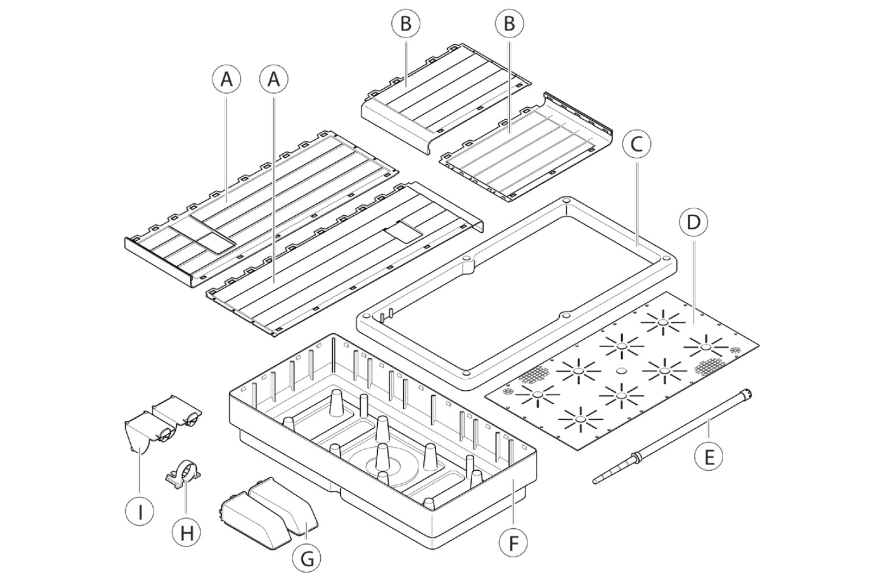

*Fig. 4 This is a caption*

### Conditions for assembling

Lorem ipsum dolor sit amet, consectetur adipiscing elit. Etiam at porta est, et lobortis sem. Duis imperdiet in nisl sed luctus. **Lorem ipsum:**

1. Condition 1
2. Condition 2
3. Condition 3

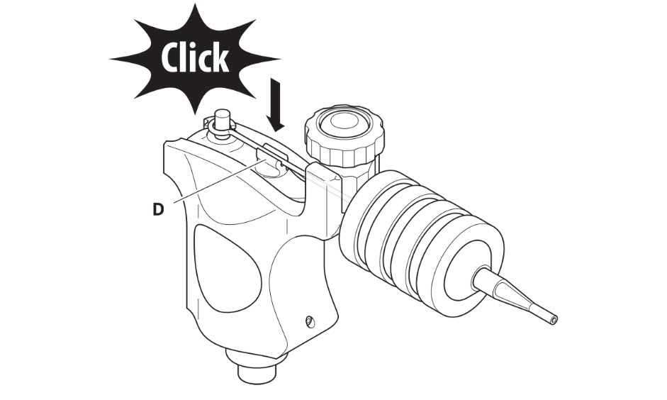

*Fig. 5 This is a caption*

### Installation of the product

**To install the product:**

1. Do this.
2. Complete an action.
3. Do that.

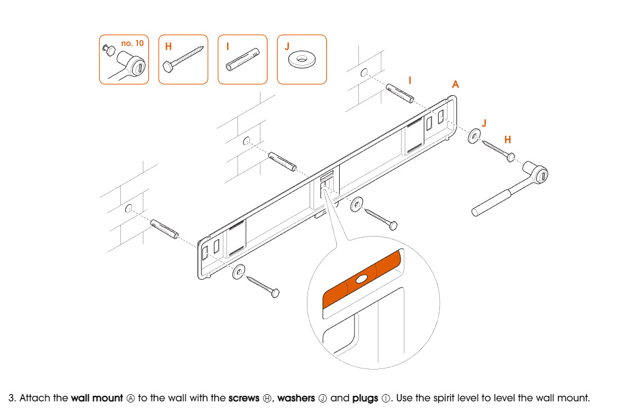

*Fig. 6 This is a caption*

## How to commission the product

Lorem ipsum dolor sit amet, consectetur adipiscing elit. Etiam at porta est, et lobortis sem. Duis imperdiet in nisl sed luctus. **Lorem ipsum:**

1. Do this.
2. Complete an action.
3. Push the **button**.

# Operation/Use

## How to use the product

### Operational environment

Lorem ipsum dolor sit amet, consectetur adipiscing elit. Etiam at porta est, et lobortis sem. Duis imperdiet in nisl sed luctus.

### Manual operating techniques

Lorem ipsum dolor sit amet, consectetur adipiscing elit. Etiam at porta est, et lobortis sem. Duis imperdiet in nisl sed luctus.

**Lorem ipsum:**

1. Do this.
2. Complete an action.
3. Push the **button**.

### Local/Remote operation

Lorem ipsum dolor sit amet, consectetur adipiscing elit. Etiam at porta est, et lobortis sem. Duis imperdiet in nisl sed luctus.

**Lorem ipsum:**

1. Do this.
2. Complete an action.
3. Push the **button**.

### Manual/Automatic operation

Lorem ipsum dolor sit amet, consectetur adipiscing elit. Etiam at porta est, et lobortis sem. Duis imperdiet in nisl sed luctus.

**Lorem ipsum:**

1. Do this.
2. Complete an action.
3. Push the **button**.

### Starting/Stopping the product’s operation

Lorem ipsum dolor sit amet, consectetur adipiscing elit. Etiam at porta est, et lobortis sem. Duis imperdiet in nisl sed luctus.

**Lorem ipsum:**

1. Do this.
2. Complete an action.
3. Push the **button**.

### Checks before using the product

Lorem ipsum dolor sit amet, consectetur adipiscing elit. Etiam at porta est, et lobortis sem. Duis imperdiet in nisl sed luctus.

**Lorem ipsum:**

* Do this.
* Complete an action.
* Push the **button**.

### Using the product

**Lorem ipsum:**

1. Do this.
2. Complete an action.
3. Push the **button**.

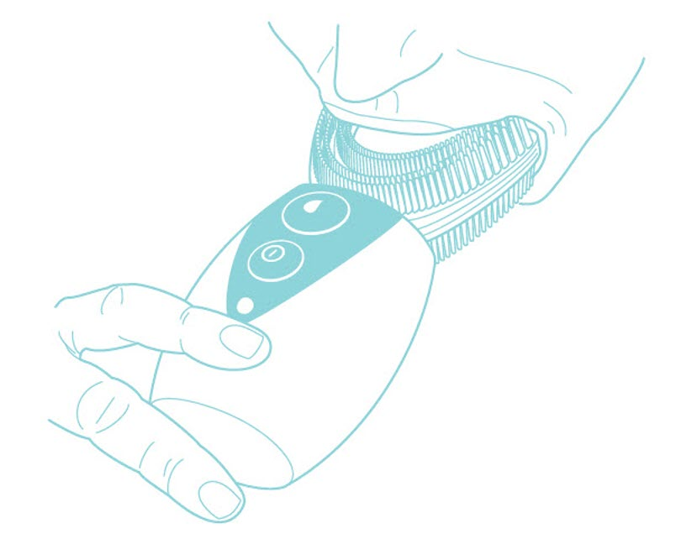 *Fig. 7 This is a caption*

## Software documentation

### Setting up the product

**To set up the product with the software:**

1. Click **[button]**.  
   The **[name]** dialog box opens.
2. When prompted to close **[software name]**, click Yes.  
   The **[name window]** window opens.
3. Click **[button]**.  
   All **[product name]** detected by **[software]** appear within the window.

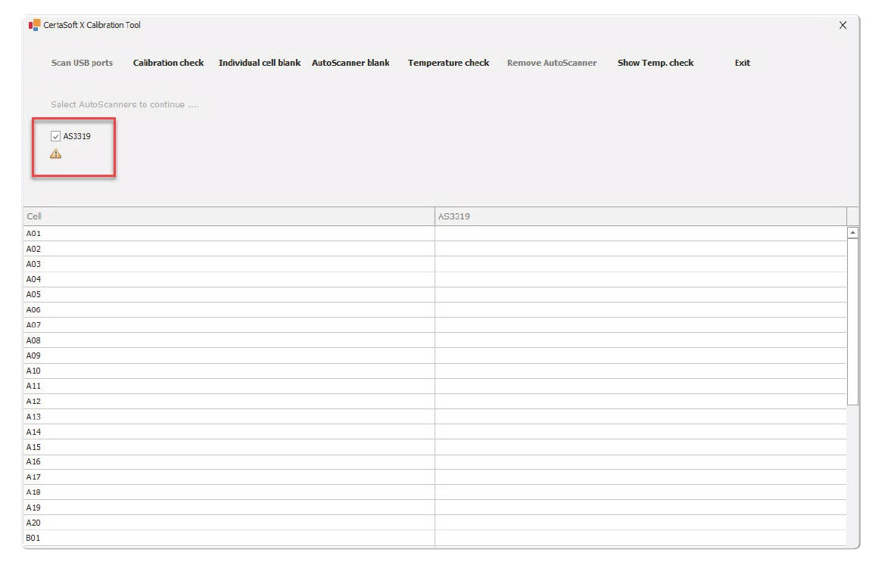

*Fig. 8 This is a caption*

### Adding products with the software

**To add products with the software:**

1. Click the **Add** button.  
   Click the **[button name]** button.  
   The **[name]** overview opens.

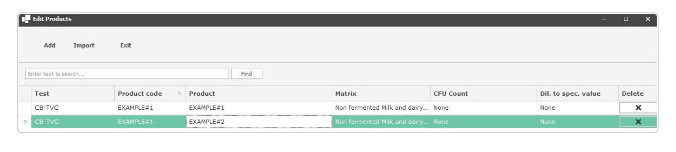 *Fig. 9 This is a caption*

1. Click **[name button].**The **[name window]** window opens.
2. Click **Import**.  
   The **Select Import File** dialog box opens.
3. Locate and select the batch file.
4. Click **Open**.

### Software settings

**To adjust the temperature of module A Ⓐ and module B Ⓑ:**

1. Click **Temp settings**.  
   The **[name]** dialog box opens.
2. In the **[name section]** section, select the device you would like to set the temperature for.
3. Click **Save**.

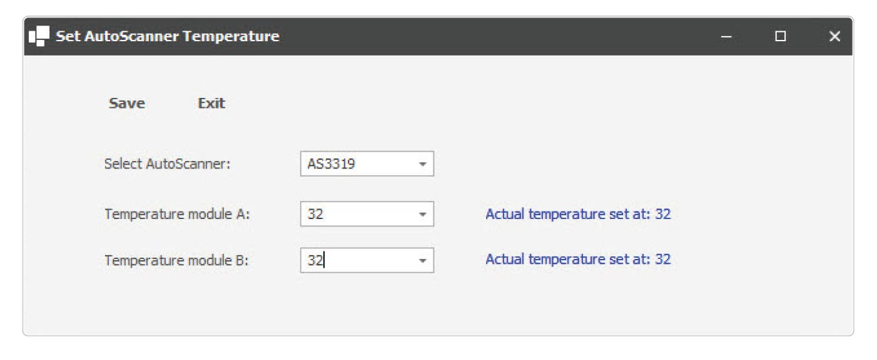  
 *Fig. 10 This is a caption*

**To generate a calibration curve:**

1. Click on the **[name/image]** icon at the top right corner of the screen.  
   The **Settings** menu appears.
2. Click on the **[name/image]** icon.  
   The **[name window]** window opens.
3. Click **Save**.
4. The **[setting]** is now visible in **[software]**.

## What to do in emergency and exceptional situations

### Emergency situation

**In case of an emergency situation:**

1. Do this.
2. Complete an action.
3. Do that.

### Exceptional situations

**In case of an exceptional situation:**

1. Do this.
2. Complete an action.
3. Do that.

# Maintenance and cleaning

**NOTICE:** Lorem ipsum dolor sit amet, consectetur adipiscing elit. Etiam at porta est, et lobortis sem. Duis imperdiet in nisl sed luctus.

## How to maintain the product

### Product maintenance by non-skilled persons

#### Replacing the [part] (e.g. battery)

**To replace the [part]:**

1. Do this.
2. Complete an action.
3. Do that.

#### Replacing the [part] (e.g. light):

**To replace the [part]:**

1. Do this.
2. Complete an action.
3. Do that.

### Product maintenance by skilled persons

#### Lubricating the product

**To lubricate the product:**

1. Do this.
2. Complete an action.
3. Do that.

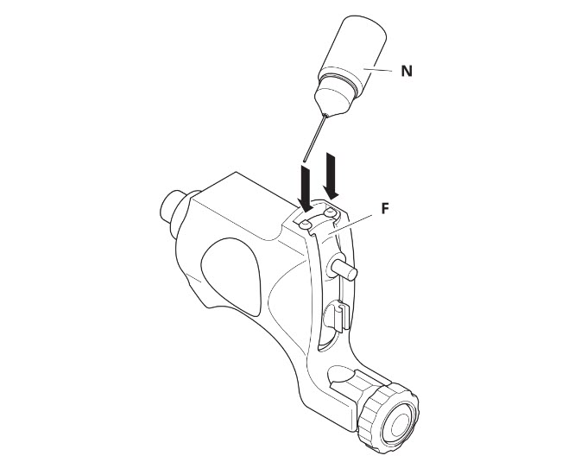

*Fig. 11 This is a caption*

### Planned maintenance

Maintenance tasks shall be done according to the following plan:

|  |  |
| --- | --- |
| Task | Frequency |
| Replacing the battery | Every 6 months |
| Replacing the light | Every 12 months |
| Lubricating the bearings | Every week |

*Table 5 This is a table*

## How to clean the product

**To clean the product:**

1. Do this.
2. Complete an action.
3. Do that.

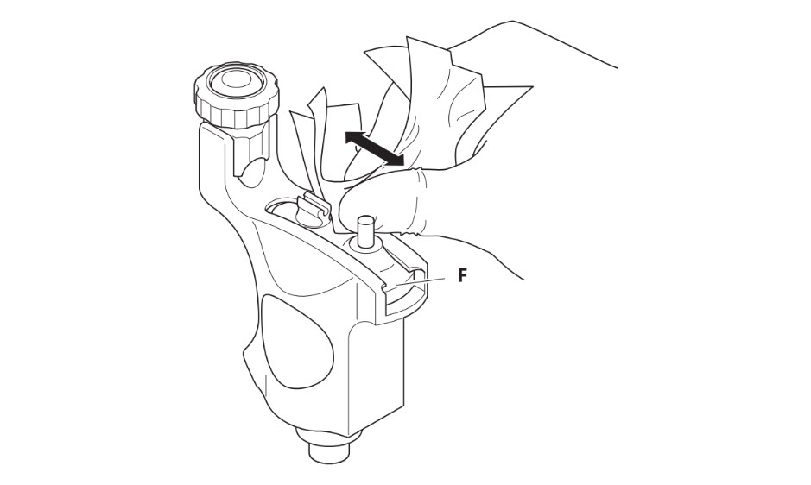

*Fig. 12 This is a caption*

# Troubleshooting and repair

## How to Identify and solve problems

### Troubleshooting and repair by non-skilled persons

**WARNING:** Lorem ipsum dolor sit amet, consectetur adipiscing elit. Etiam at porta est, et lobortis sem. Duis imperdiet in nisl sed luctus.

|  |  |  |
| --- | --- | --- |
| Error | Cause | Solution |
| Product does not start | **Part A** is broken | Replace **part A**. See *7.2.1.4 Replacement of Part A* |
| … | … | … |

*Table 6 This is a table*

### Troubleshooting and repair by skilled persons

**WARNING:** Lorem ipsum dolor sit amet, consectetur adipiscing elit. Etiam at porta est, et lobortis sem. Duis imperdiet in nisl sed luctus.

|  |  |  |
| --- | --- | --- |
| Error | Cause | Solution |
|  |  |  |
|  |  |  |

*Table 7 This is a table*

## How to Repair the Product

### Repair by non-skilled persons

**WARNING:** Lorem ipsum dolor sit amet, consectetur adipiscing elit. Etiam at porta est, et lobortis sem. Duis imperdiet in nisl sed luctus.

#### Specials tools

The following tools are needed for reparation tasks:

|  |  |
| --- | --- |
| Task | Tools |
| Task 1 | Tool 1 Tool 2 Tool 3 |
| Task 2 | Tool 1 Tool 2 |

*Table 8 This is a table*

#### Equipment

The following equipment is needed for reparation tasks:

|  |  |
| --- | --- |
| Task | Tools |
| Task 1 | Equipment 1 Equipment 2 Equipment 3 |
| Task 2 | Equipment 1 Equipment 2 |

*Table 9 This is a table*

#### Materials

The following materials are needed for reparation tasks:

|  |  |
| --- | --- |
| Task | Tools |
| Task 1 | Material 1 Material 2 Material 3 |
| Task 2 | Material 1 Material 2 |

*Table 10 This is a table*

#### Replacement of part A

**To replace part A:**

1. Do this.
2. Complete an action.
3. Do that.

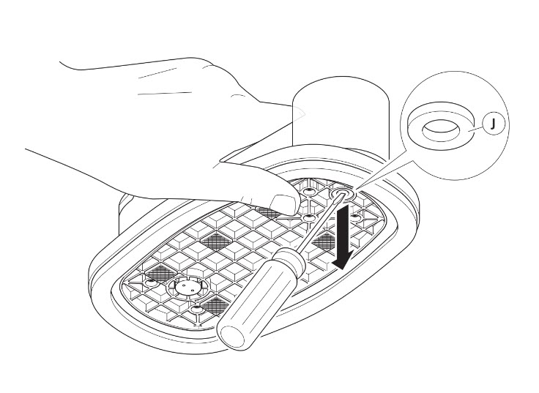

*Fig. 13 This is a caption*

#### Replacement of part B

**To replace part B:**

1. Do this.
2. Complete an action.
3. Do that.

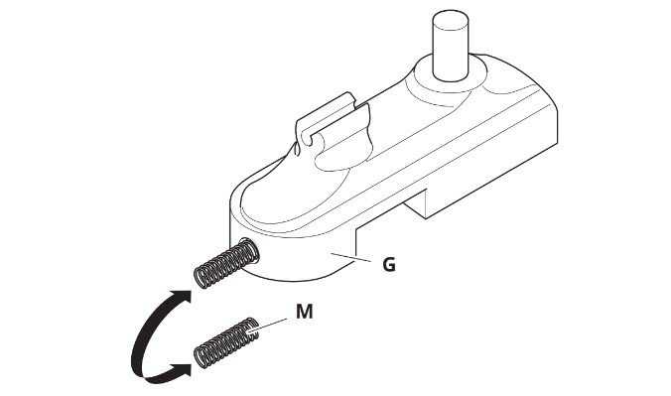

*Fig. 14 This is a caption*

### Repair by skilled persons

**WARNING:** Lorem ipsum dolor sit amet, consectetur adipiscing elit. Etiam at porta est, et lobortis sem. Duis imperdiet in nisl sed luctus.

#### Replacement of part C

The following tools are needed for reparation tasks:

|  |  |
| --- | --- |
| Task | Tools |
| Task 1 | Tool 1 Tool 2 Tool 3 |
| Task 2 | Tool 1 Tool 2 |

*Table 11 This is a table*

#### Equipment

The following equipment is needed for reparation tasks:

|  |  |
| --- | --- |
| Task | Tools |
| Task 1 | Equipment 1 Equipment 2 Equipment 3 |
| Task 2 | Equipment 1 Equipment 2 |

*Table 12 This is a table*

#### Materials

The following materials are needed for reparation tasks:

|  |  |
| --- | --- |
| Task | Tools |
| Task 1 | Material 1 Material 2 Material 3 |
| Task 2 | Material 1 Material 2 |

*Table 13 This is a table*

#### Replacement of part C

**To replace part C:**

1. Do this.
2. Complete an action.
3. Do that.

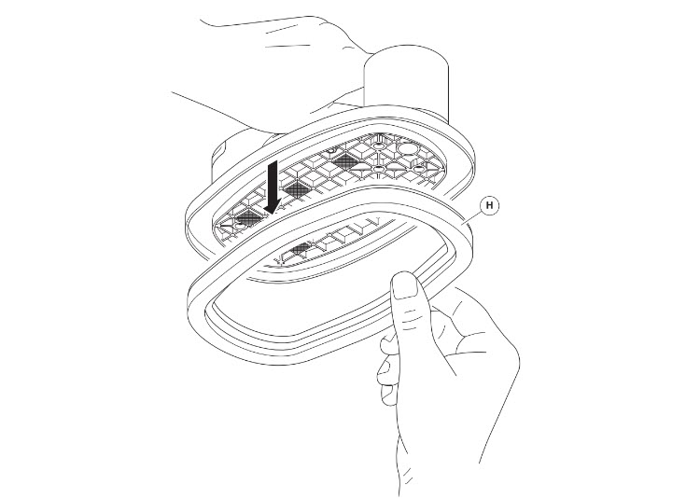

*Fig. 15 This is a caption*

#### Replacement of part D

**To replace part D:**

1. Do this.
2. Complete an action.
3. Do that.

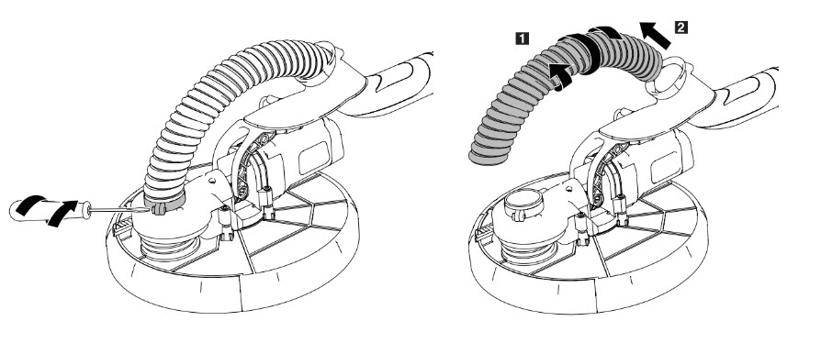

*Fig. 16 This is a caption*

# DISPOSAL

## How to disassemble the Product

**To disassemble the product:**

1. Do this.
2. Complete an action.
3. Do that.

## How to recycle parts

**To recycle part A:**

1. Do this.
2. Complete an action.
3. Do that.

## How to dispose the product

**To dispose the product:**

1. Do this.
2. Complete an action.
3. Do that.

### Disposal of electronic components

**To dispose electronic components:**

1. Do this.
2. Complete an action.
3. Do that.

### Disposal of packaging waste

**To dispose packaging waste:**

1. Do this.
2. Complete an action.
3. Do that.

### Disposal of batteries

**To dispose batteries**

1. Do this.
2. Complete an action.
3. Do that.

# Appendix A. Supplied accessories, consumables and spare parts

## Supplied accessories

|  |  |  |
| --- | --- | --- |
| Image | Name | Article Number |
|  |  |  |
|  |  |  |
|  |  |  |
|  |  |  |

## 

## Consumables

|  |  |  |
| --- | --- | --- |
| Image | Name | Article Number |
|  |  |  |
|  |  |  |
|  |  |  |
|  |  |  |

## 

## Spare/replacement parts

|  |  |  |
| --- | --- | --- |
| Image | Name | Article Number |
|  |  |  |
|  |  |  |
|  |  |  |
|  |  |  |

# Appendix B. Related documentation

|  |  |  |  |  |
| --- | --- | --- | --- | --- |
| # | Document Title | Version # | Location | Author |
|  |  |  |  |  |
|  |  |  |  |  |
|  |  |  |  |  |
|  |  |  |  |  |

# Glossary

[Explain the meaning of all terms used in this document]

|  |  |
| --- | --- |
| Term | Meaning |
|  |  |
|  |  |
|  |  |
|  |  |

# Index

**A**

Aftereight 532

Appendum

*Appelsap* *223*

**B**

Borneo 321

*Bravo 134*

*Bohemian 23-24*